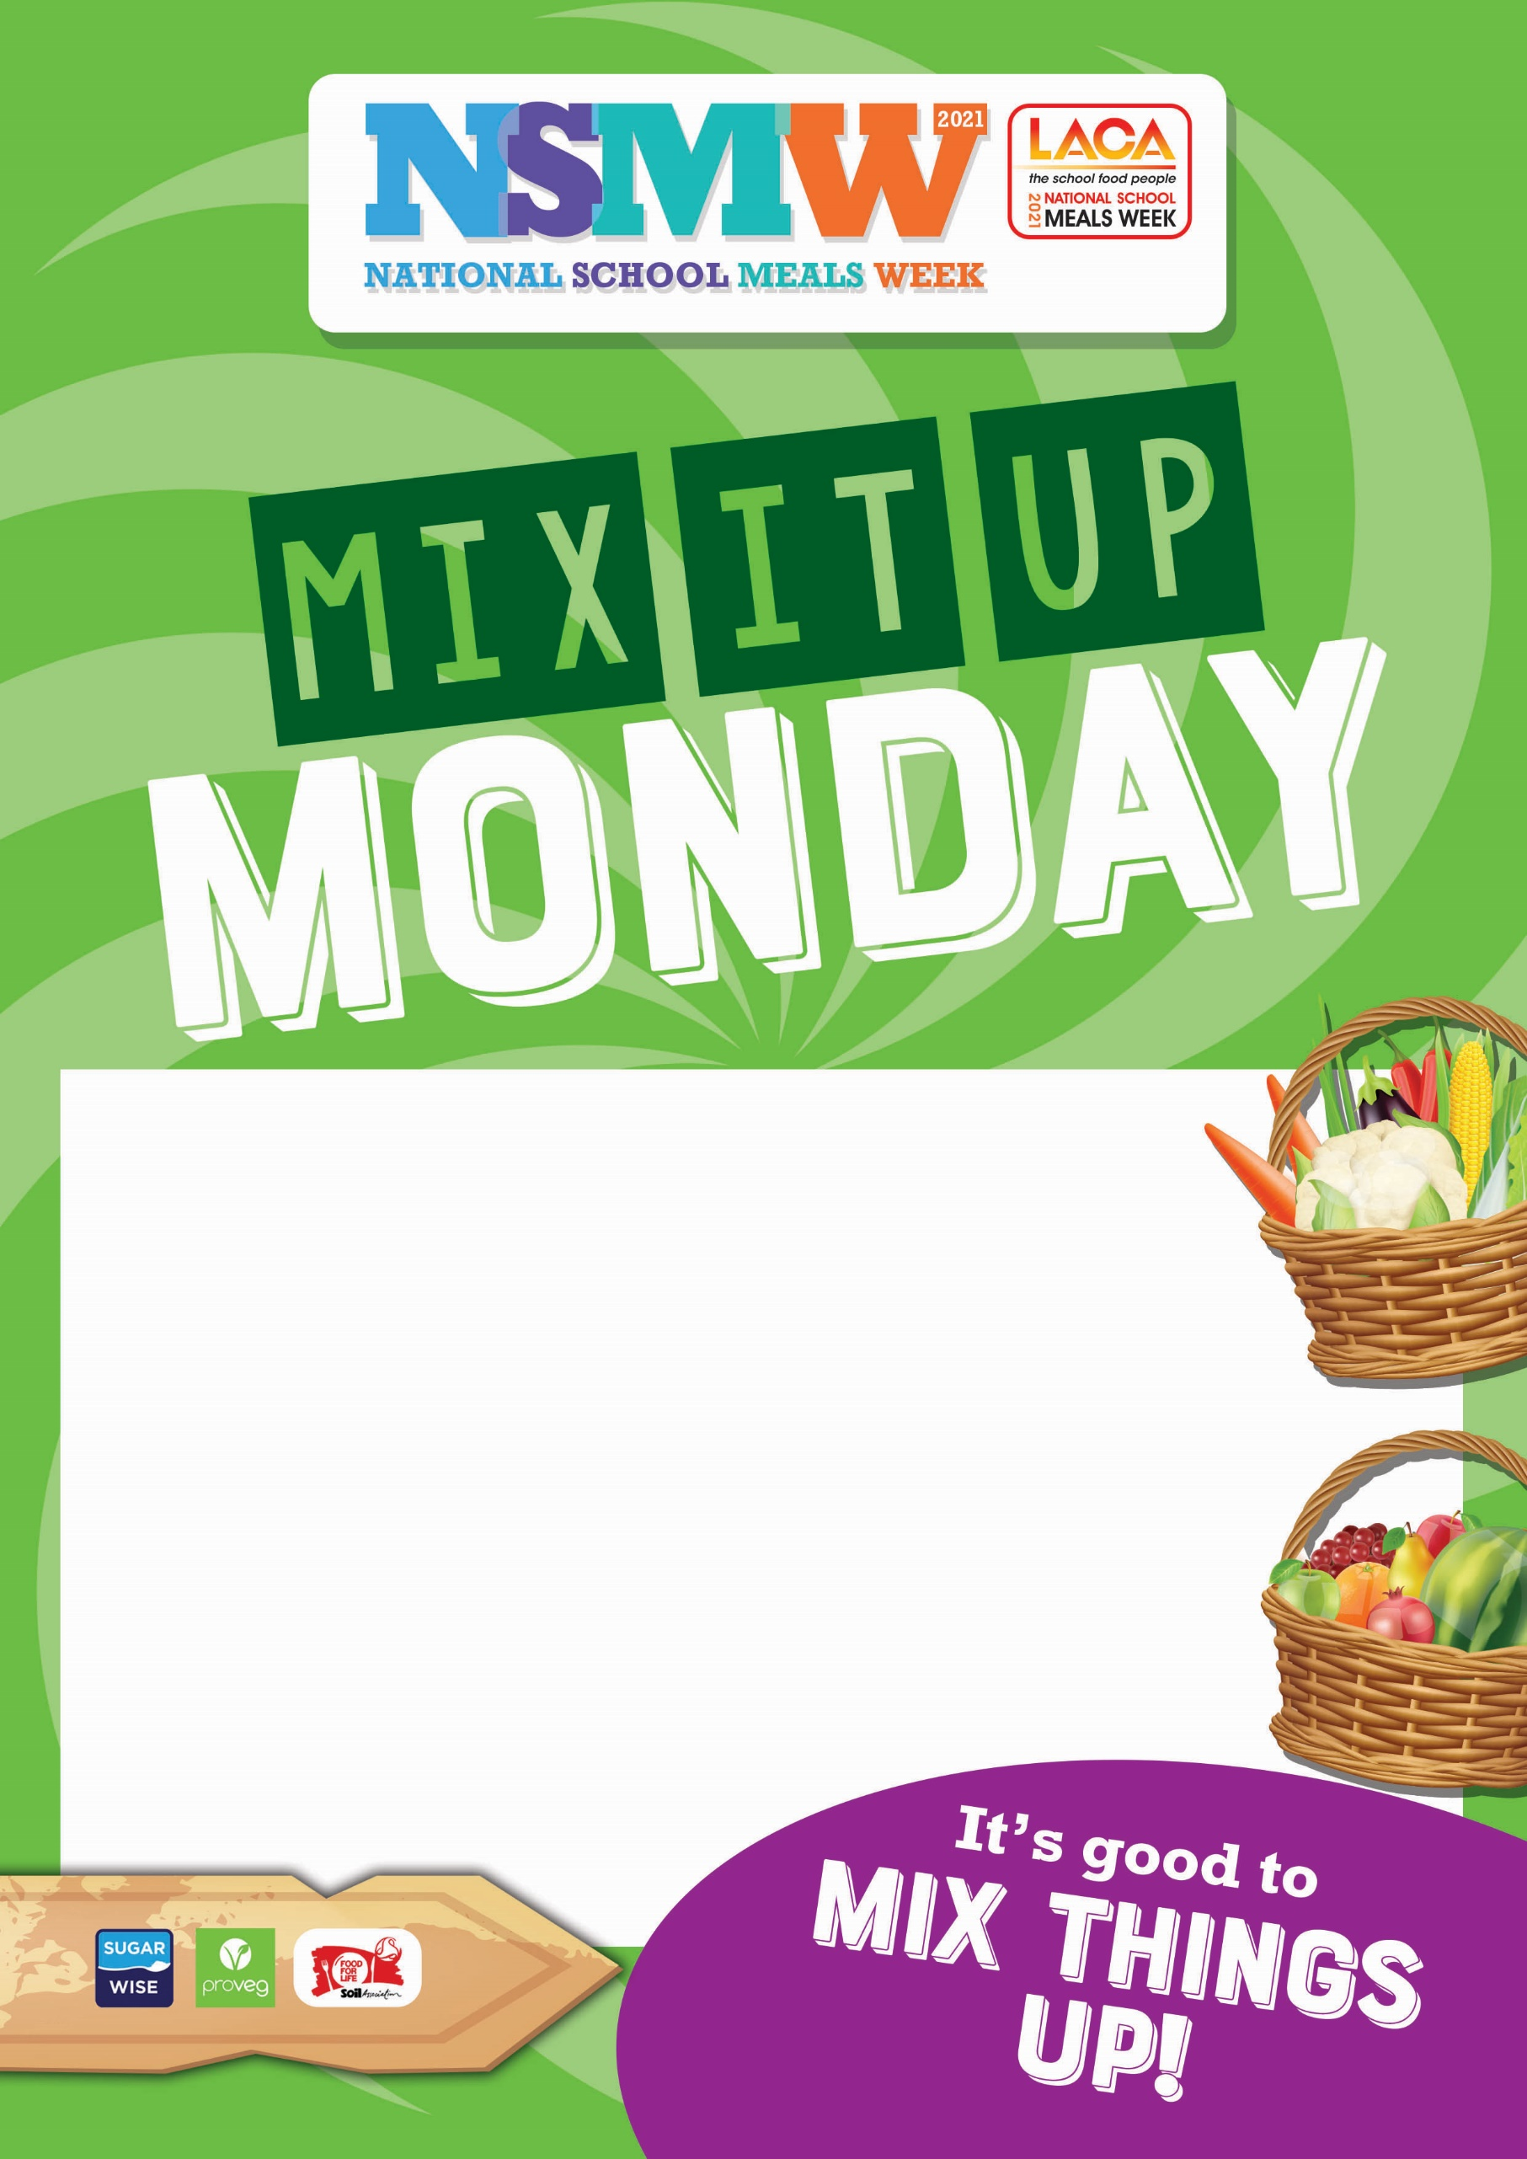
Dear Parent,

We are having a special menu on (insert date here) to celebrate National School Meals Week 2021. We would be delighted if your child could attend. There will be fun activities on the day too.
We will be serving

(Insert menu here)

LACA’s National School Meals Week is the one week in the year when we celebrate all that is great about today’s school food, with this year’s activities scheduled for 8th – 12th November 2021.
This year the focus is on the fun and social aspect of school meals as well as getting children back into the dining rooms following the interruptions and isolation of the past 18 months.

Please fill in the details below to let your school know you are taking part. If you are entitled to free school meals your child will receive the meal in the normal way. (edit as required)

(Insert meal price, days of the week, how to pay, how to inform school)

